**CREATE DB TABLE BY USING DATA ELEMENT TYPE**  
**( TOP-DOWN APPROACH):**  
1. Execute SE11.  
2. Select the radio button database table.  
3. Provide the table name ( Eg: ZDB_TOP_DOWN ) and click on Create.

[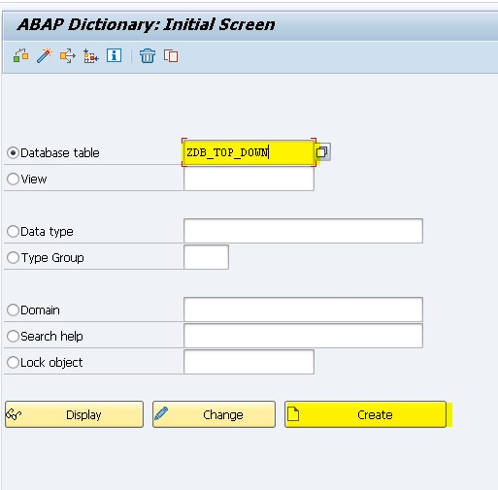](https://4.bp.blogspot.com/-uu_G2PqZC6M/V-oXt8PPyhI/AAAAAAAABe8/afN1BZvuPmoY42rzloov9MUa3Wj0bVpCwCLcB/s1600/DB%2B-%2BTOP%2BDOWN.jpg)

4. Provide short description ( Eg: Employee table ).  
5. Provide delivery class as "A".  
6. Select Display / Maintenance Allowed.  
7. Click on Fields tab.

[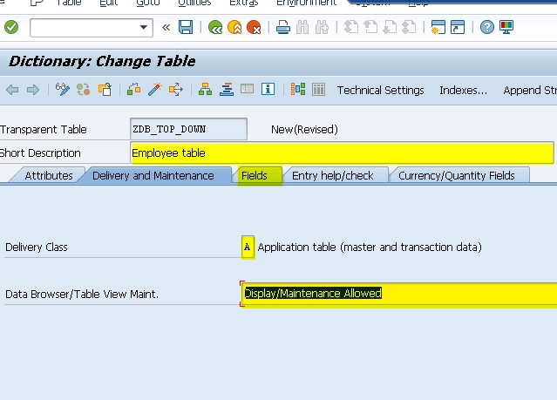](https://4.bp.blogspot.com/--1LH66_jevE/V-oYeGwLHUI/AAAAAAAABfA/Eha02D4EL0w6xpcqSeaoZaBpIwg4dcingCLcB/s1600/DB%2B-%2BTOP%2BDOWN1.jpg)

7. Provide the field name and if the field is key field then select the     check box of key.  
8. Provide the data element ( Eg: ZDE_TD_EMP_ID ) which you       want to create.

](https://4.bp.blogspot.com/--2RPPYFvU-Q/V-oZc0U9lII/AAAAAAAABfM/FZKBKI2QgNkek5CUx1h1JZfUBM7kxiq9gCLcB/s1600/DB%2B-%2BTOP%2BDOWN2.jpg)

9. Double click on data element. Click on Yes. Save and Enter.             Click on Yes.  
10. Provide short description ( Eg: Employee Id ).  
11. Provide the Domain name ( Eg: ZDM_TD_EMP_ID ) which           you want to create.

[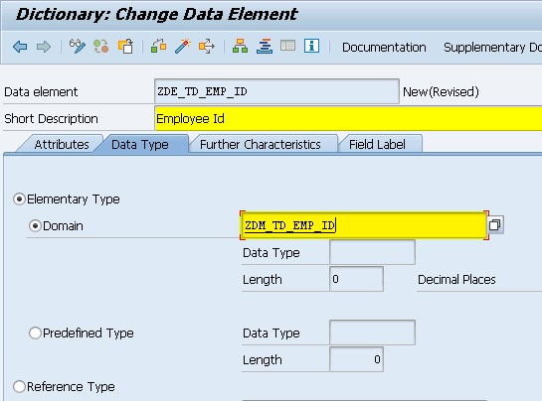](https://3.bp.blogspot.com/-jFg1t6C6_o8/V-oawZTGGhI/AAAAAAAABfQ/D8CEj55Gy4468YNJV6AVIyuuqay_lIcEQCEw/s1600/DB%2B-%2BTOP%2BDOWN3.jpg)

12. Double click on Domain name. Click on Yes. Save. Click on           Yes.  
13. Provide the short description ( Eg: Employee Id ).  
14. Provide data type ( Eg: CHAR ) and length ( Eg: 10 ).

[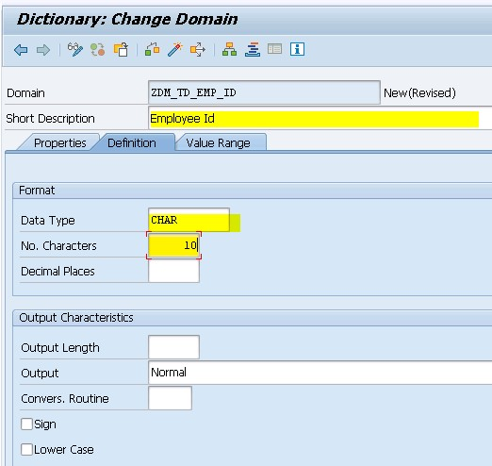](https://4.bp.blogspot.com/-n5Skul_RBVM/V-ocTj5jOrI/AAAAAAAABfc/RGKgwuuAErwmdkezoMG9--TXY6ot_QR8gCLcB/s1600/DB%2B-%2BTOP%2BDOWN4.jpg)

15. Save, check and Activate the domain.  
16. Click on back.  
17. Save, check and Activate the data element.  
18. Click on back.  
19. Repeat the same steps for all other fields.  
20. Save and Check the table.  
21. Display the warning message enhancement category for table           missing.  
22. Click on back.  
23. In the menu bar click on Extras. Select Enhancement category.  
      Select the radio button Can be enhanced ( Character type or             numeric ). Click on Copy.

[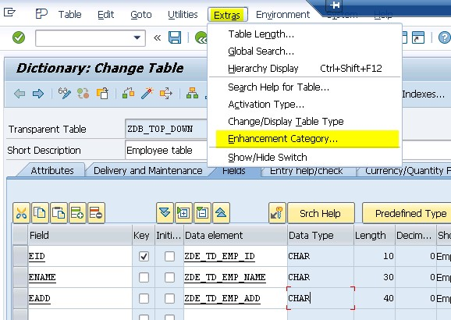](https://2.bp.blogspot.com/-haRDmBvKGz0/V-ofHUMaHGI/AAAAAAAABfo/1gyhfA247ecVbHgJd1EI_A-AVVsd8Pm9wCLcB/s1600/DB%2B-%2BTOP%2BDOWN5.jpg)

[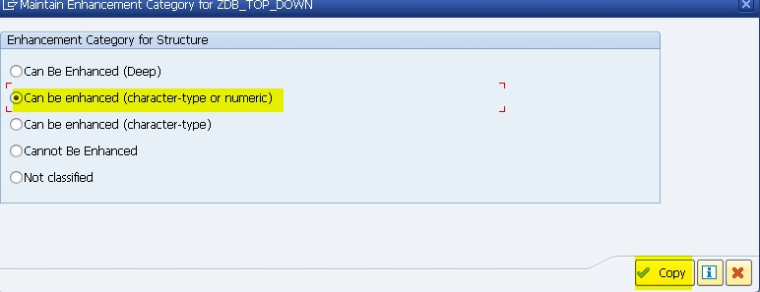](https://3.bp.blogspot.com/-dd57L8_TINA/V-ofLy_xO_I/AAAAAAAABfs/SrX-1DB_xdEkwf6eXW6sLxpFhn8U0XDNgCLcB/s1600/DB%2B-%2BTOP%2BDOWN6.jpg)

24. Now click on Technical Settings in the application tool bar.  
25. Provide the data class as 'APPL0' and size category as '0'.

[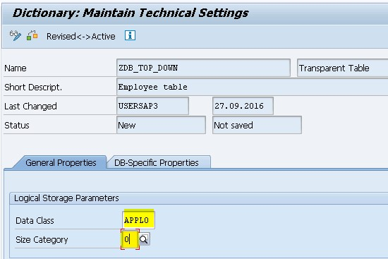](https://1.bp.blogspot.com/-6-jBfk__m-s/V-ofyTvv2uI/AAAAAAAABfw/0d-jygnvbjktA7_V0b4GsgHhL_s4z9RkgCLcB/s1600/DB%2B-%2BTOP%2BDOWN7.jpg)

26. Click on Save. Click on back.  
27. Save, Check and Activate the table.  
  
Steps to create Entries in the table:  
  
1. In the menu bar click on Utilities. Select table contents. Select         create entries.  
2. Provide the data and click on save.  
  
Steps to Display the data in the table:  
  
In the menu bar click on Utilities. Select table contents. Click on Display.